Technical Development Program for
Process Performance Engineers

Clinker Uniformity
Case Study
Part C
Raw Meal Preparation

Version 20 April 2016
LafarageHolcim Ltd.
Cement Industrial Performance
Quality Management and Optimization

Raw grinding system

Feed silo/bins set-up

The raw mill feed system comprises 6 circular and 2 interstitial silos:

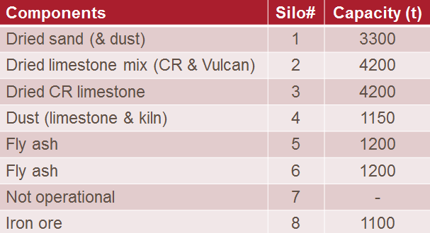

The plant reports the following regarding feed bins/silos performance:

- The limestone extraction rate of bins/silos #2 & #3 is not consistent (erratic) when the filling level is low.

- The iron ore extraction rate (bin/silo #8) is also erratic. A preliminary study shows that bridging and rat-holing are the phenomenon behind the issue.

- The trial for using the bin (silo) #7 for wet sand handling failed. Reviewing the bin design we can conclude that this is not surprising.

- The limestone/kiln dust bin/silo outlet was modified and, moreover, the implementation of a new feed rate control system (based on a Coriolis type flow meter) has proved to be beneficial. This success leads the plant to do the same modifications to the fly ash feed bin/silo #5 & #6.

Remember the raw mix characteristics:

Material | Source | Comments | Avg. use in raw mix  [%] | Moisture  [%]
CR Limestone | Own, but external quarry, transported by barges on the sea |  | 81.3 | 10.8
Vulcan Limestone | External supplier, transported by barges | Used in small quantities, sweetener, | 3.6 | 8.9
Fly ash | Various sources |  | 9.6
Sand | Natural, wet |  | 2.7 | 8.4
Iron correctives |  |  | 0.5
Various alternative raw materials |  |  | 2.3

Raw grinding system

The raw grinding system process flowsheet is shown below

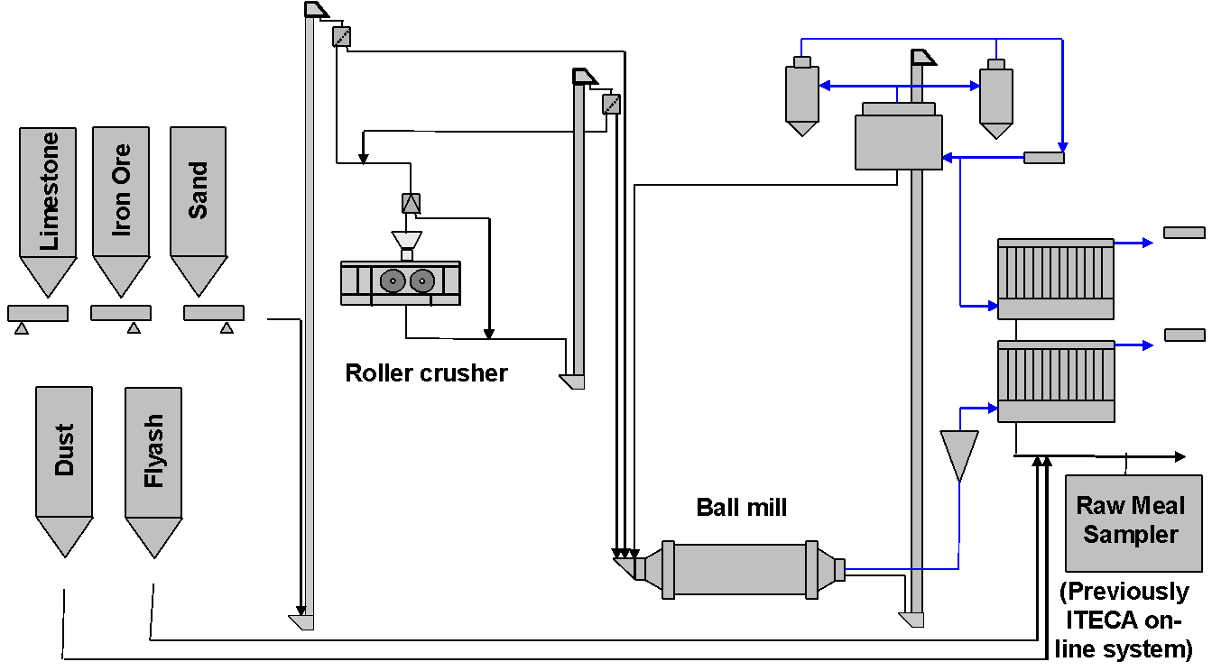

Task C
Address the following questions.

- Which do you think are the causes for the erratic flow in the limestone bins/silos? Propose next steps to confirm the causes.
- Name three measures to solve the issues in the iron ore bin/silo #8.
- Think about the reasons behind the failure of the feed bin/silo #7 design. Name three of those reasons.
- Analyse the raw mix proportioning control (quality control), it can help to read also the Case Study PART E.
  - Which are the weak points in the system?

